Typical Operation Condition KT88 – 2:

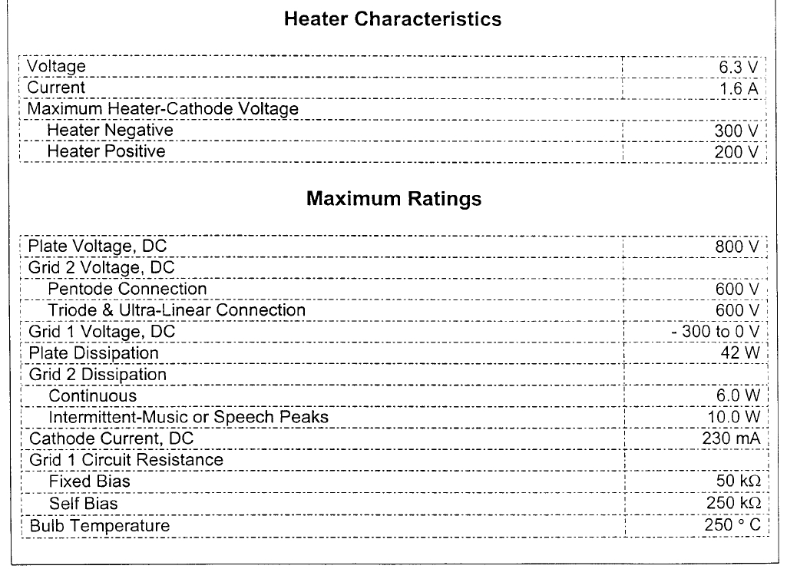

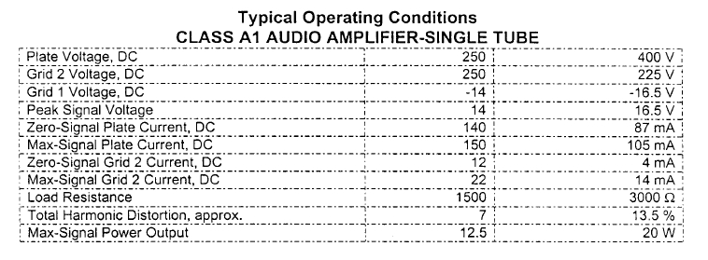

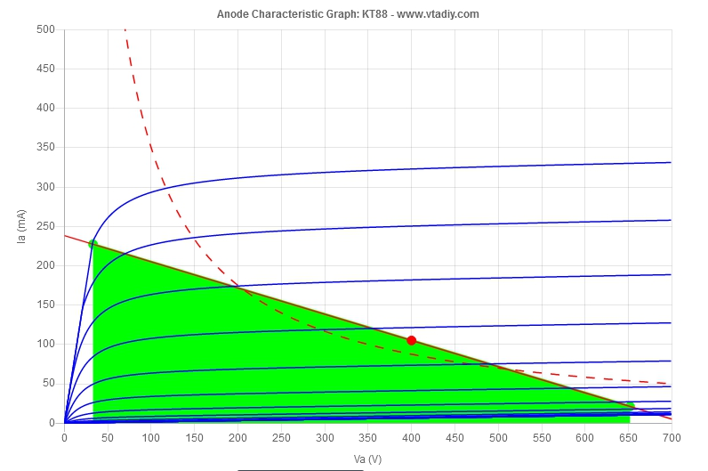
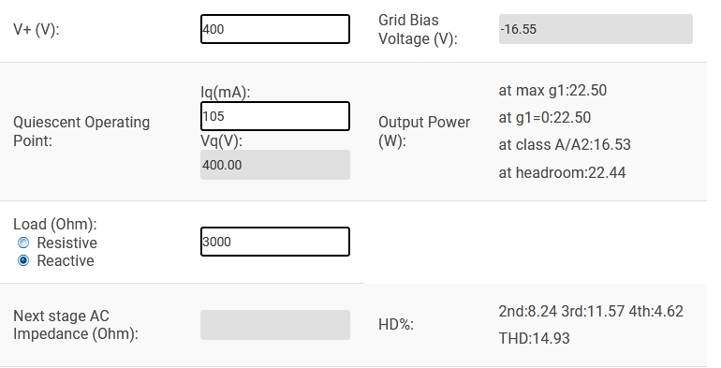

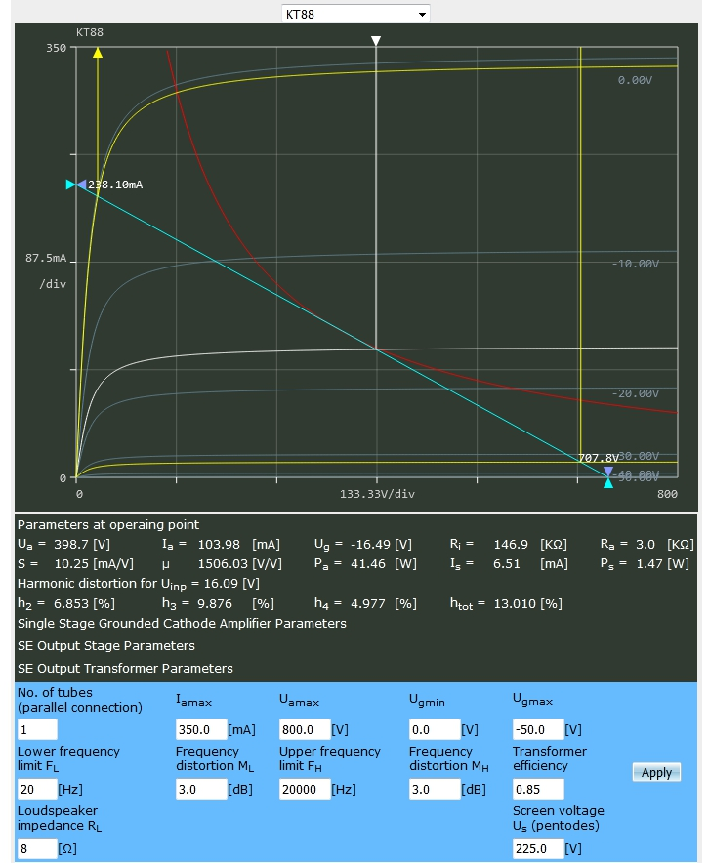

VA Rl = 708 V
VA max = 652 V
VAq = 400 V
VA min = 33 V
VA* = VA max – VA min = 652 – 33 = 619 V
IA Rl = 238 mA
IA max = 227 mA
IAq = 105 mA
IA min = 21 mA
IA* = IA max – IA min = 227 – 21 = 206 mA
Input = 32 Vpp
Rl = 3k

Watt:
(VA* X IA*) : 8 = ( 619 X 0.206 ) : 8 = 16 W

( VA* : 2.83 ) X ( IA* : 2.83 )
( 619 : 2.83 ) X ( 0.206 : 2.83 ) = 218.72 X 0,073 = 16 W

[(VA* : 2.83) X (VA* : 2.83)] : Rl
[( 619 : 2.83 ) X ( 619 : 2.83 )] : 3000 = 15.97 W

[(IA* : 2.83) X (IA* : 2.83)] X Rl
[( 0.206 : 2.83 ) X ( 0.206 : 2.83 )] X 3000 = 15.97 W

