http://www.chambonino.com/modify/mod1.html

CHAMP ELECTRONICS -" THE VINTAGE VALVE AMP HOSPITAL"

NOTTINGHAM, ENGLAND

THE CONVERSION OF EL503 TUBE AMPLIFIERS TO USE THE EL36/6CM5/EL360 FAMILY OF TUBES

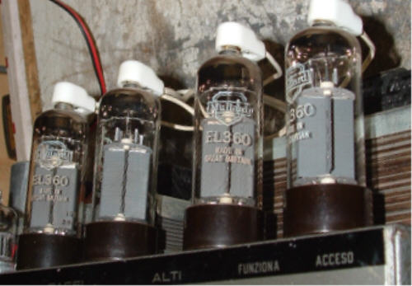

Hello everybody, my name is John Chambers and I run “Champ Electronics, The Valve (Tube) Amp Hospital” here in Nottingham, UK. I have worked on, repaired/serviced, built and restored valve (sorry tube!) amplifiers nearly all my life. Having started at about the age of 9 and I am now 55.
I have provided herewith some useful information on the converting of EL503 tube amplifiers to the EL36/6CM5/EL360 family of tubes:

Before continuing to read on with this text please note the following:
1. Whilst the end-results of all my experimenting herewith are excellent, a considerable amount of technical knowledge and “know-how” is needed. Maybe a little metal/woodworking knowledge would be useful too?
2. You will be working with potentially lethal voltages! What follows may also not be a suitable undertaking for some people.
3. Most companies that used the EL503 output tube (the Belgian company Faylon and the German Dynacord being just two examples) most probably chose this tube for its short, stubby, fairly beefy, relatively low voltage specifications enabling a smaller overall height of their amplifiers? This being the case these modifications will not necessarily be appropriate unless case/chassis modifications are made too.
4. I have also not done any experimenting with them in self (cathode) bias mode. On the basis that the EL36 is not very linear for audio applications (especially in single ended self bias mode), and even though in push-pull most of this linearity is cancelled out, I still cannot make any guarantees to their performance in the self bias mode.
Please also note important points at the end of the text.

Mr. John Geloso (Italy) actually produced a model with a pair of EL36/6CM5’s (as too did Philips): a G-231-A, rated at 25 watt undistorted, 150 volts on the screens and 310 volts on the plates, fixed bias. The one I have here actually produces 36 watts quite easily before clipping!
Now having collected and gotten all my Geloso amplifiers up and running (33 of them to date and 5 fully re-built), they use a multitude of output tubes in pairs, these being: EL36/6CM5’s, ECL82/6BM8’s, EL34’s in various circuits from 30 – 100 watts, (Yes! A pair for 100 watts, fixed bias with a 375 volt stabilized screen supply, 1000 volts on the plates!!) EL84/6BQ5’s, 807’s, 6L6’s, 6V6’s, 6N7’s, 6146’s and finally EL503/8278’s.
Mr. Geloso did in fact do 2 models (and matching slaves) using the EL503 output tubes. One of these was the G1/1070-A model, with just a pair rated at 70-90 watts. The EL503’s are in fixed bias with about 325 volts on both the plates and screens. The other was the G1/1110-A model with a quad of the EL503’s running on the same voltages but with a rated output power of 110-140 watts. (This was to the best of my knowledge the only Geloso model to use a quad of output tubes). I presently own a pair of each of these models.
I did have at the time (I have sold them off since doing these modifications), 3 NOS matched pair of EL503’s and a pair of used odd ones. These had all cost me a fair bit of money and I still needed more! They are getting very rare nowadays, though they turn up now and then on Ebay but the prices are extortionate. A while ago I decided to spend some serious time on one of the smaller amps (the model with just a pair) and see if I could come up with some descent results using cheaper and (or) more readily available tubes!
There’s not very much information on the EL503, though it is on Frank Philips’s site. However this only shows a single configuration using a pair in self bias with a plate/screen voltage of 265 giving 40 watts from a 2.4k plate to plate load. This tube has a high gm factor of 23 mA/V, making it a hard act to follow!!
As there seems to be no data on the EL503 in fixed bias, and with various plate/screen voltages, I have no idea what the plate loads are on these two Geloso types. I could have put an a/c voltage up the primary to get a fairly close ratio figure, but I just decided to go ahead with the many output tube types for “real world” results.
As I am able to design and wind my own transformers I decided to do the experiments with separate power supplies for now, so I could play around with voltages and try and achieve the desired results; the end idea being to rewind the mains transformers with the voltages I ended up with. As the EL503 is on the Magnavol base my first choice was the EL509/EL519. The amp itself had only a swing of 10-28 volts for the negative bias, so my first move was to change this for a 0-55 volts swing through two 20 turn pots; one for each tube. I also put two 1ohm, 1% resistors in the cathodes (one per tube) for reading off each tube current direct on a 1ma/1mv scale.
Having re-wired the bases for the EL509’s I ended up with 135 volts on the screens, 400 volts on the plates and a bias of about 30 volts. These were brilliant and actually were the best results of all I had tried from a power point of view. I was seeing about 80 watts across the 8 ohm load. Changing the load to 4 ohms saw 110 watts RMS, basically meaning that the plate load was more suited at this setting. The problem now was that there was no way that the top cover would fit with these 2 tubes towering out of the chassis like a pair of sky scrapers!
Next job was to rip out the Magnavol bases and replace with a pair of good old octals. This left the field wide open for trying a multitude of output tubes. 6L6’s just didn’t want to know, no matter what I tried, EL34's were way out on the plate load. 6146’s would have been great as the cover would have fitted with these, but unfortunately these were dreadful, requiring much greater plate voltages in the 600 – 750 volt range of which I didn’t want to do, plus I could also tell that whatever the plate load of this amp was, it was far from correct for the 6146 family too……..shame.
KT66’s, KT88’s etc, (the list goes on and on) were all tried, and whilst some results were ok with other tubes, I still wasn’t happy.
Next saw another rewire of the octals for a pair of 6AV5’s. These are an old TV horizontal deflection tube with a plate dissipation of 11 watts. With 170 volts on the screens, 300, 350, 400 and 425 volts on the plates respectively, they performed quite well. I was looking at about 50 watts with the 350 volt plate option, and the plate load seemed to suit too. Nevertheless, no matter what else I did they would give no more.
Three full days had now passed and after many hours and cups of tea I was just about to give up and resign myself to having to pay out more money for EL503’s when......... my eye suddenly fell on my collection of old TV tube types EL36/EL360’s and I thought Mmmmmmm!!??
I now wondered how hard I could push a pair (or quad) of these?
Rewire number "?" (I’d lost count by now!?) took place. I left the screen supply at the previous 170 volts and started off with a 300 volt plate voltage, biasing the two tubes for zero crossover distortion and was quite pleased at seeing about 52 watts RMS @ 8ohms; plus the plate load seemed to suit as well as any impedance change either way (4 or 16 ohms) showed less results. This was starting to look good! A change of plate voltage to 350 brought things up quite a bit so I thought “go for it”, here’s 425 plate volts, now let me see if you can handle it!? And there it was: 24.6 volts RMS @ 8ohms which equates to 75.64 watts from just the pair!! Checking cathode currant at 35 m/a per tube (no signal), out went the lights to look for those tell tailed red spots and nothing!!
As the maximum screen voltage for an EL36/6CM5/EL360 is 250 volts, I decided to make one more final adjustment and raise the screen voltage to 200. This required yet another re-bias of course, and with a brand new pair of Mullard EL360's biased at 30ma cathode currant per tube, this baby was doing 27.4 volts RMS @ 8 ohms! This is a whopping 93.84 watts from just the pair and still no red spots! I'm impressed! In fact these have now just surpassed the original EL503's!!
Finally a short time later I converted one of my G1/1110-A's to a quad of EL36's and the results on this were staggering too. An impressive 38.5 volts RMS @ 8 ohms = 185.28 watts!! This too is better than the original quad of EL503's which managed 142 watts tops at best!
Pushing the EL36 family of tubes this hard may reduce their lifespan? But what I can tell you is that it has been some 5 weeks now (as at 20/11/05) since I finished the experiments, and these two amplifiers have been on virtually continuously. They are still holding in there with no change in any way. As the EL36/6CM5's are available 10 a penny! Who cares for now, anyway!
One other point here. In my case, on this brand (Geloso) of amplifiers using EL36’s instead of the original EL503’s, the top cover would still not fit. However with these tubes being slim, I can cut the tube base holes a little larger, mount the bases from underneath with some 12 mil ferrules, and then the tubes will drop through to give enough clearance.
As I said earlier, I had ended up with various plate/screen and bias voltages. To achieve this I used a 1kv/a transformer that I wound a long time ago with numerous tapings/currants of many types for the very purpose of massive, serious experimentation.
Once I’d reached the desired voltages and findings, I proceeded to remove the mains (power) transformers from the 4 Geloso amplifiers in question and simply re-wound them to my own needs. One of the photos shows a re-wound power transformer with the extra screens (grid 2) winding on two tags previously used for the 20 volt bias winding. (I have brought the new 40 volt bias winding out on fly leads, no more tags left!) Also, the very simple independent screen supply can be clearly seen.
The photos show the actual quad mod running on completion. The scope photo shows it just clipping at 38.5 volts @ 8 ohms. The main smoothing capacitors are even keeping the clipping point flat with no ringing coming over the top of the caps whatsoever! (I used 2 x 330uf @ 450 volts in parallel to achieve this, at this level the ripple on the HT line is about 1,225 ma!)
As with all electronic experimentation, there are components hanging out everywhere. Nevertheless, it goes without saying that the rebuilds won’t look like this!
I am now ready to re-build all 4 of these amplifiers as and when, and then eventually display them on this website.
If you do attempt this modification it is not difficult at all with, as I say, “some technical knowledge/know how”. However, having the design knowledge and winding facilities for transformers myself, it is of course convenient for me to do this. Nevertheless it can still be done as follows. To achieve the necessary voltages just do the following:
1, Check the a/c off load voltage of the HT winding? Deduct this figure from 325 and what you have left you will need to source a transformer of the remaining volts @ about 400 – 500ma for a pair of tubes (or 900 – 1000ma for a quad). In series with your original transformer this will give you the 425 volts DC plate supply (on load). Don’t forget you will also most probably have to up-rate the main smoothing capacitors to 450 – 500 volt ones (about 250uf for just a pair of output tubes or around 500uf for a quad) and not forgetting to check the other caps further down the HT chain. These may require a change too. Don’t worry if the whole HT chain rises a bit as well, as this only helps with the drive to the output tubes. Apart from possibly the HT caps down the line, everything else will be fine.
2, You will need to source another small transformer of 150 volts. 50ma is ample as this is only for the screens of the two (or quad of) output tubes. With a simple small bridge rectifier and a cap of 100uf @ 250 volts, remove the screen grids feed from the existing HT supply and place it here. It is essential and critical that the screens are fed from this separate supply of 200 volts (plus/minus 10 volts).
3, Apart from the obvious hardware changes like the tube bases and bringing the plate (anode) leads out to the top caps of the EL36’s the only other issue is the bias rail.
In my case the bias winding on the power transformers were only 20 volts; not sufficient to achieve a 50 – 55 volts DC negative rail. I simply re-wound mine to 40 volts.
A lot of fixed bias circuits are usually quite high and are deliberately reduced accordingly. You will need to check this right on the bias diode/bridge output directly. If you have 45 volts or more then that is fine. If not, you will need to re-think this; possibly with a very small, few milliamps 40 volt transformer to give the higher needed voltage. Don’t forget the smoothing caps voltages along the bias chain too!?
If your amplifier in question derives it’s bias supply through a resistor from the main HT winding (as some do), you can change this to get the higher bias voltage, but I would personally recommend the small separate transformer way as being better. The other method is of a much higher impedance, and also tends to sag as the main HT winding drops with currant drawn.
You may notice that on the sketch of the 2 (or 4) bias potentiometers, that one end of them is on ground!? In theory this is not a practical thing to do as this would allow the pot to completely shut down the bias of the connected tube! I have however done this on purpose, as it again keeps the bias impedance as low as possible. Needless to say after completion of the mod it should be powered first without the output tubes in place, by metering grid one negative volts on each tube base (pin 5) and winding all the pots to maximum voltage first. Then after putting the tubes in, work backwards checking cathode current at each tube cathode 1 ohm resistor (pin 8). Set them all to 30 ma. (You may need to re-do this a couple of times as the tubes settle.) If you feel uncomfortable with this, simply lift the ground of each pot through a 10k resistor per pot or a common grounded one of 2.2k.
The EL36 family of tubes were originally designed for TV line output usage (although Philips did make an amplifier using them for audio in class AB1, even though their own data shows them as class B for audio!?).
Their ratings are usually max 250 volts plate and screen, but with a 7kv peak pulsed plate voltage. They normally rate in as a 12 watt plate wattage, but there is a lot of talk out there that they can (and in fact do) handle considerably more.
The way I have ended up running these tubes is with 425 volts (plate), 200 volts separate grid 2 (screens) supply, and having a very accurate low impedance critical bias adjustment per tube, at 30 ma cathode currant, (combined plate/grid 2 currants, no signal). They seem to be quite happy at this, and in class AB1 too!
I have sketched some schematic drawings of the necessary changes; to most people they are self explanatory.
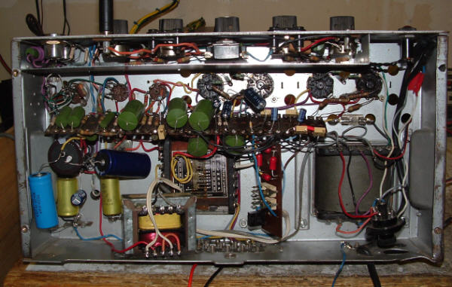

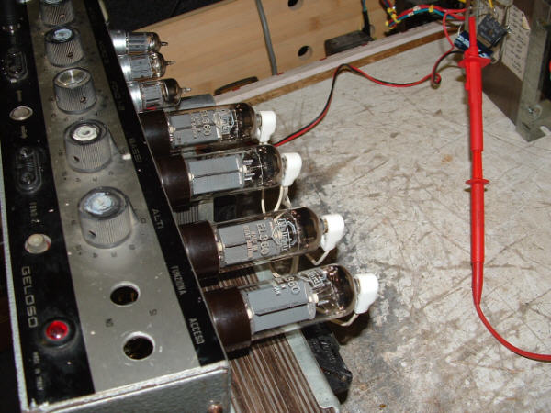
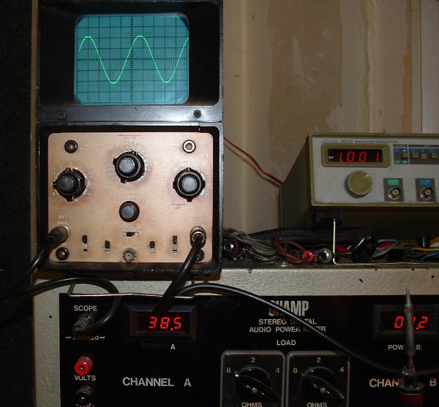

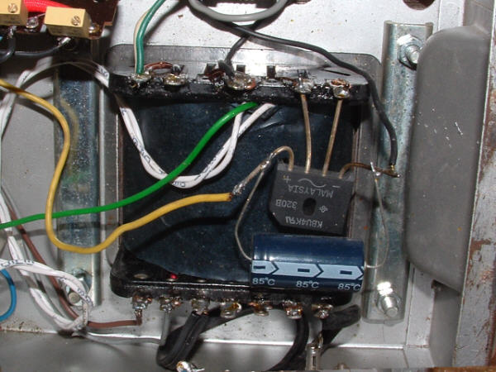

Lastly I would imagine a question that most people would ask is: "OK, so much for the modifications but what does the end result sound like in real life terms?"
My answer to this would simply be: "I have here in the workshop 2 specially designed, tuned (designed and built by myself) speaker cabs of which one contains a pair of 12” drivers whilst the other a pair of 15” drivers. With either of the two amplifiers set to a total load of 4 ohms (both cabs) they both sound thunderous on bass guitar and noticeably better/punchier than with the original EL503’s!!"
What more can I say?

One final point here: If the thought of 4 mains transformers seems and sounds a bit off-putting, just bare this in mind - the transformer for the screens supply need only be about 50 ma (this is enough even for 4 tubes) and will be small. The bias transformer would be very small. It is only the second HT transformer that might be on the larger size? However as the secondary of this only needs to make up the difference of the original power transformer HT up to 325 volts, it actually won't be quite that big!? If you think about the cost of EL503’s then that should be more than enough incentive to carry on!!
Good luck with your modifications:- John

Schematic Drawings



